Parent
Handbook

Welcome
First and foremost, a very warm welcome to The Paragon!

We are delighted that your child is joining this happy and vibrant school. We are convinced he or she will love it here. In years to come, we hope all our children will look back and say of their school years, ‘Those were some of the happiest days of my life.’ That’s not just wishful thinking, we are determined to make that a reality.
Joining a new school means learning a lot of new procedures, rules and names - not easy! We hope this handbook familiarises you with life at The Paragon. If you have any questions at all, please don’t hesitate to ask. We want everyone, mums and dads included, to settle quickly into our school family.
Rosie Allen
Head of School

Aims and Ethos

The Paragon’s Mission Statement:
Our aims are defined in the school’s Mission Statement:
- To be an exciting and dynamic school, in which children acquire a thirst for knowledge and a love of learning.
- To promote the importance of moral, spiritual and social values, inspired by the school's underlying Christian ethos.
- To deliver a broad and balanced education for every child, which maximises their academic, creative and sporting potential.
- To value every individual's talents and interests, encouraging children to take pride in their own achievements while also celebrating those of others.
- To be a school that is outward looking - building links with parents and the local community, as well as appreciating the rich diversity of cultures from around the world.
- To be a happy school where children really feel they belong - where they can laugh, be spontaneous and enjoy being children.
- To enable those leaving The Paragon to move on to Prior Park College as confident, capable, compassionate and independent minded young people.

Our ethos:
The Paragon cultivates a love of learning and encourages independent and creative thinking. We see our job as preparing children for life with all its opportunities and challenges - building the high self-esteem, strong moral values and sense of social responsibility that will help them grow into adults that succeed in the widest possible sense.

The Paragon was founded as a Christian school and the Christian ethos underpins our values and attitudes, both inside and outside the classroom.

Our aim is to help all children distinguish between right and wrong, to develop a sensitivity and awareness of the needs of others and, above all, to make them feel loved and valued as a unique human being with their own gifts to offer the world.
Contents
Aims and Ethos 2
KEY INFORMATION 4
How to Contact Us 4
Communication 5
How The School is Organised 6
The School Day 7
Before and After School Care 7
Drop Off and Pick Up 8
Pick Up 8
School Site 11
Traffic 14
Absence 16
Extra-Curricular 17
Sport, PE and Matches 18
School Lunches 21
Snacks 21
Nut Allergies 21
Medical Matters 21
Uniform 22
Lost Property 23
Hair 23
TEACHING AND LEARNING 23
Homework 24
Curriculum Letters 25
Curriculum Meetings 26
Reports 26
Parents’ Evenings 26
Celebrating Excellence 26
Learning Support 27
Educational Visits 27
Outdoor Learning 28
Music 28
PASTORAL CARE 29
Behaviour Aims 30
Sanctions 31
Bullying 31
GENERAL INFORMATION 32
Spiritual Life 32
Assemblies 32
Library 32
House System 33
School Council 33
Holiday Activities 33
Home-School Links 34
Parent and Teacher Association 35
Compliments and Complaints 35
IAPS Membership 35
School Crest 36

contents

KEY INFORMATION

How to Contact Us

Reception
Most contact with the school will be through reception. The receptionist is in school from 8.00am until 5.30pm, Monday to Friday, during term time. The school telephone number is 01225 310837. There is an answer phone when there is no-one in the office and this is checked regularly during term time. The school email address is: reception.paragon@priorparkschools.com.

Headmaster’s PA/Registrar
The Headmaster’s PA and Registrar, Mrs Rebecca Braithwaite, is available from 8.30am until 5.00pm, Monday to Friday during term time, and may be contacted by telephone on the number above or by email: rbraithwaite@priorparkschools.com.

Reporting absence
In the event that your child is unwell, please telephone reception on every morning of sickness to let us know. The receptionist will inform the class teacher. (See Absence and Medical Matters for details.)

Finance
Financial queries are dealt with by Mrs Alison Rabbitts, the Fees Clerk. She may be contacted during the hours of 8.30am until 5.00pm, Monday to Friday, on 01225 837491 Ext 324, or by email: arabbitts@priorparkschools.com.

Music Department
If you would like your child to start learning an instrument our Director of Music, Mrs Sarah Kettlety, can be contacted by email: skettlety@priorparkschools.com. Instrument lesson timetables are published on a weekly basis. For queries about music lesson times please contact our administrator, Mrs Celia Mike: cmike@priorparkschools.com.

Sports Department
Enquiries regarding PE and Games lessons, swimming and sports clubs, should be directed to the Sports Department by telephoning the school office or by emailing the Director of Sport, Mr Toby Goodman: tgoodman@priorparkschools.com. You can also check the most up to date information regarding matches, by looking at the school’s website, www.paragonschool.co.uk, and viewing the Calendar. The team sheets are accessed by clicking on the relevant fixture.

The Chair of the Governing Body
The Prior Park Schools are overseen by an experienced body of Governors chaired by Mr Michael King, who may be contacted via the following address:

Mr A M H King,
Prior Park College,
Ralph Allen Drive,
Bath BA2 5AH.

Matters specific to The Paragon are dealt with by The Paragon Local Governance Committee (LGC), which meets once a term and is chaired by Governor, Mrs Jane Singleton.

Communication

Parents may discuss any issues concerning them with their child’s class teacher at the start or end of the school day. It may be necessary to arrange an appointment to discuss some matters in more detail. Staff can be contacted by phone (the school’s number is 01225 310837) or by email. See the school website for staff email addresses.
If, during the school day, you have an urgent message for a teacher, please contact the receptionist so that the message may be passed on, rather than emailing the teacher. Teaching commitments often mean that teachers will not see emails until later in the day.
Please note that teachers are not always able to respond to emails outside school hours.

School notices are communicated in a number of ways:

Website
The Paragon website address is www.paragonschool.co.uk. The site sets out our stall, explaining to prospective and existing parents The Paragon’s ethos, as well as providing details about the organisation and procedures at the school.

The ‘Current Parents’ menu at the top of the homepage links to information of particular interest to current parents. It includes information such as the week’s menu, clubs currently on offer, sports fixtures and team sheets (in ‘Calendar’). In addition, the latest news from the school, holiday clubs, term dates, uniform and box office for booking tickets to school events.

Parents’ Weekly Bulletin
The bulletin contains the bulk of information which parents require. It is important that parents read the bulletin each week. The first section features whole school notices. There is also a section for each year group, in which class teachers provide information about the activities undertaken in class and give notices to parents. A link to the latest bulletin is emailed to parents on Friday afternoons. The current and recent bulletins are available on the Weekly Bulletin page of the website (within ‘Current Parents’).

Text Messages
Urgent messages are sent to parents using SMS text messaging.

Sports Information
See ‘Sport, PE and Matches’ for information regarding sports.

Pupil Planner
For all age groups the Pupil Planner is an important means of communication between home and school:

- It records reading progress.
- It carries messages and letters to and from school.
- It details homework assignments.
- It provides a means for parents to communicate with teachers regarding homework, changes of routine/pick-up, special occasions etc.

The Prep School Planner has a number of useful pages of information regarding The Paragon’s routines, timetables, dates and required equipment. Prep School pupils increasingly take responsibility for their Pupil Planner. It helps them to:

- Plan their work
- Keep track of their homework
- Manage their time
- Monitor reading
- Record achievements
- Review progress
- Set personal targets

How The School is Organised

We have Pre-School (3 - 4 year olds), Pre-Prep (4 - 7 year olds) and Prep (7 - 11 year olds) departments.
Squirrels Pre-School
Squirrels Pre-School is run by a Pre-School Leader supported by experienced assistants. ‘Pre pre-school’ children (those turning 3 during the academic year) attend for a minimum of two afternoon sessions per week, and pre-school children (those turning 4 during the academic year) attend for a minimum of three sessions in the autumn term and increase to four sessions in the spring and summer terms.
Pre-Prep
Children join our Pre-Prep department in the September after their fourth birthday. A dedicated class teacher teaches the core curriculum while French, Music, PE and Games and Art are taught by specialist teachers. The Pre-Prep consists of Reception, Year 1 and Year 2.
Prep
At seven years old, children join the Prep department which consists of Years 3, 4, 5 and 6. Much of the curriculum is taught by the class teacher but ICT, Modern Languages, Music, PE, Games, Art and Philosophy are taught by specialist teachers.
Prior Park Schools
We are one of three Prior Park Schools that share the same educational vision and Christian values. The other two schools in the group are:
- Prior Park College - a co-educational Catholic senior school in Bath for day and boarding children aged 11-18
- Prior Park School, Gibraltar – an independent, co-educational Catholic/Christian senior school for day children aged 12-18, opened in Gibraltar in September 2016
The Paragon pupils make use of the facilities at our Senior School, Prior Park College. They are used weekly for sports lessons and matches, and pupils use the Science, Music, Design & Technology and other facilities on an ad hoc basis. Prior Park College teachers take our pupils for some lessons, including Science, sometimes at The Paragon and also at the College. The Carol Service and end of year Celebration are held at Prior Park College.

The School Day

 | Morning | Afternoon
Squirrels | 9.00am – 12 noon | 1.00 – 3.00pm
Reception, Year 1 | 8.40am – 12 noon | 1.00 – 3.00pm
Year 2 | 8.40am – 12 noon | 1.00 – 3.15pm
Years 3 and 4 | 8.40am – 12.30pm | 1.45 – 3.45pm
Years 5 and 6 | 8.40am – 12.30pm | 1.45 – 4.00pm

Before and After School Care

Schedule

Mornings
Before-school childcare | 8-8.30am before-school care takes place in the IT Room or Library. There is no need to book, but a charge of £2 will be added to the school bill for every use.
Drop off | 8.20am onwards  Pre-Preps and Preps go directly to classrooms.
Registration | 8.40am

Afternoons
Pre-Prep: | After school clubs  (times vary)  Locations specified on Clubs List | SuperPirates  (end of school day until 6.00pm)  Squirrels Pre-School
SuperPirates available from 3.00 – 6.00pm
Squirrels Pre-School
Prep: | After school clubs  (times vary)  Locations specified on Clubs List | Homework Club/Study Club  4.15 – 5.00pm  Study Club: 5G classroom  (top of Lyncombe House)  Homework Club: 6I (by front door of Lyncombe House)
SuperPirates available from 4.00 – 6.00pm
Squirrels Pre-School

SuperPirates - Registration and Booking
Our after-school wrap-around childcare is provided by the children's events company, SuperPirates. We are very impressed by the high standard of children's entertainment and care that they provide.
They run from 3-6pm, Monday to Friday, during the school term and are based in the Squirrels Pre-School classroom. If you would like your child to attend, first register with SuperPirates. Once registered, you can complete a booking form to select your days. You can add extra days at any time, but to guarantee a place you should book with notice. Prices are £6.30 for one hour, £9.30 for two hours and £11.30 for three hours. There is a 10% sibling discount. To start the process, go to their website: www.superpirates.co.uk/paragon/. If you have any queries, please don't hesitate to get in touch with them -paragon@superpirates.co.uk.

Drop Off and Pick Up

Minibus Service
A free minibus ferrying service is in operation from Prior Park College pavilion (8.20am) and Prior Park Garden Centre (8.25am) in the mornings. At Prior Park College, the children should wait in the cricket pavilion if it is raining. In order to help us provide the required amount of buses, please email reception if you would like your child to use this service, stating where your child will catch the bus. (reception.paragon@priorparkschools.com)

Prior Park College runs a daily transportation service for its pupils, covering a number of local towns and villages. It is sometimes possible to arrange for Paragon pupils to use this service. Details of the routes are available on the Transport Services section of the PPC website. There is a charge for this service. If interested, please email Wendy Paradise at PPC (wparadise@priorparkschools.com). Please inform the receptionists once your child has been booked onto this service, for their records.

We encourage parents to car share whenever possible. The owner of Prior Park Garden Centre has kindly agreed to allow The Paragon parents to use the garden centre car park at drop off. Parents may park there and walk their children to school - please display the school crest on the dashboard of your car. Please note this arrangement is only applicable at the start of the day and is only for parents who are walking their children to school.

Pick Up

Squirrels and Pre-Prep children are dismissed from their classrooms. If picking up from Squirrels or Reception at 1.00pm, children should be collected from their class teacher, in their classroom, not from the playground.

Prep children are formally dismissed by their class teacher from the playground/play area unless they have opted to take part in one of the after-school clubs. Parents are asked to collect their children from the playground/play area or wait for them at the top of the steps beside Lyncombe House, before accompanying them to their car.

If you arrange for your child to be picked up by someone else in advance, please inform the child’s class teacher. Any late changes of arrangement will be relayed to the teacher via the receptionist. In the latter case, please contact the receptionist, by phone or via email, detailing who is picking the child up and at what time. Children can only be collected by their parent unless the school has had specific instructions that their child will be collected by a third party. Parents may provide a ‘blanket’ permission letter if someone else regularly picks up their child.

When collecting your child during the school day, please go directly to the reception desk. The receptionist will check that permission has been granted and arrange for your child to come to the reception desk to be signed out. Parents must not take their child from the playground or classroom.

Parents are requested to be mindful of the safety of all pedestrians in the school grounds,
particularly the children, when dropping off and picking up. Children and parents must always use the zebra crossing. Please do not drop off and pick up on the drive and, if entering the school as a pedestrian, turn immediate right after the entrance gate and walk through the dell. As we are situated in a residential area, we follow a one-way system through the school grounds and surrounding roadways which we hope minimises any inconvenience to the local residents. The map indicates which routes to take (see Traffic).

Pupils are dismissed at the following times, from the following places:
Squirrels Pre-School | Collect from Squirrels | 1pm/3pm
Reception and Year 1 | Collect from classrooms | 3pm
Year 2 | Collect from outside classrooms | 3.15pm
Years 3 and 4 | Dismissed at corner of playground/area beside steps | 3.45pm
Year 5 and 6B | Dismissed at corner of playground/area beside steps | 4.00pm
6I* | Dismissed from patio beside 6I

*On Friday afternoons, Years 5 and 6 attend Prior Park College for afternoon sports and finish at 3.45pm, when they may be collected by parents from the College or return to school on minibuses.

If it is raining heavily, the children are dismissed from the following places:

Squirrels, Reception, Year 1 & Year 2 | Direct from classrooms
Year 3 | Front door of Lyncombe House
Year 4, Year 5 | Lyncombe House side entrance/cloakroom
Year 6 | Front door of Lyncombe House

Supervision after school
Please make sure you supervise your child after dismissal. Particularly close supervision is required on Thursdays when hot drinks are sometimes served to parents in the Play Area. Children should not enter the Pre-Prep patio area after school has finished.

Door locking system
During the school day external doors are kept locked. Doors around the school unlock automatically during drop off and pick up times. Prep pupils are given a code to use during the school day. The white switch beside the door needs to be pressed to release the door when leaving a building.

Collecting during the school day
When collecting your child during the school day, please report to the reception desk. The receptionist will check that permission has been granted and arrange for your child to come to the reception desk to be signed out. Parents must NOT take their child from the playground.

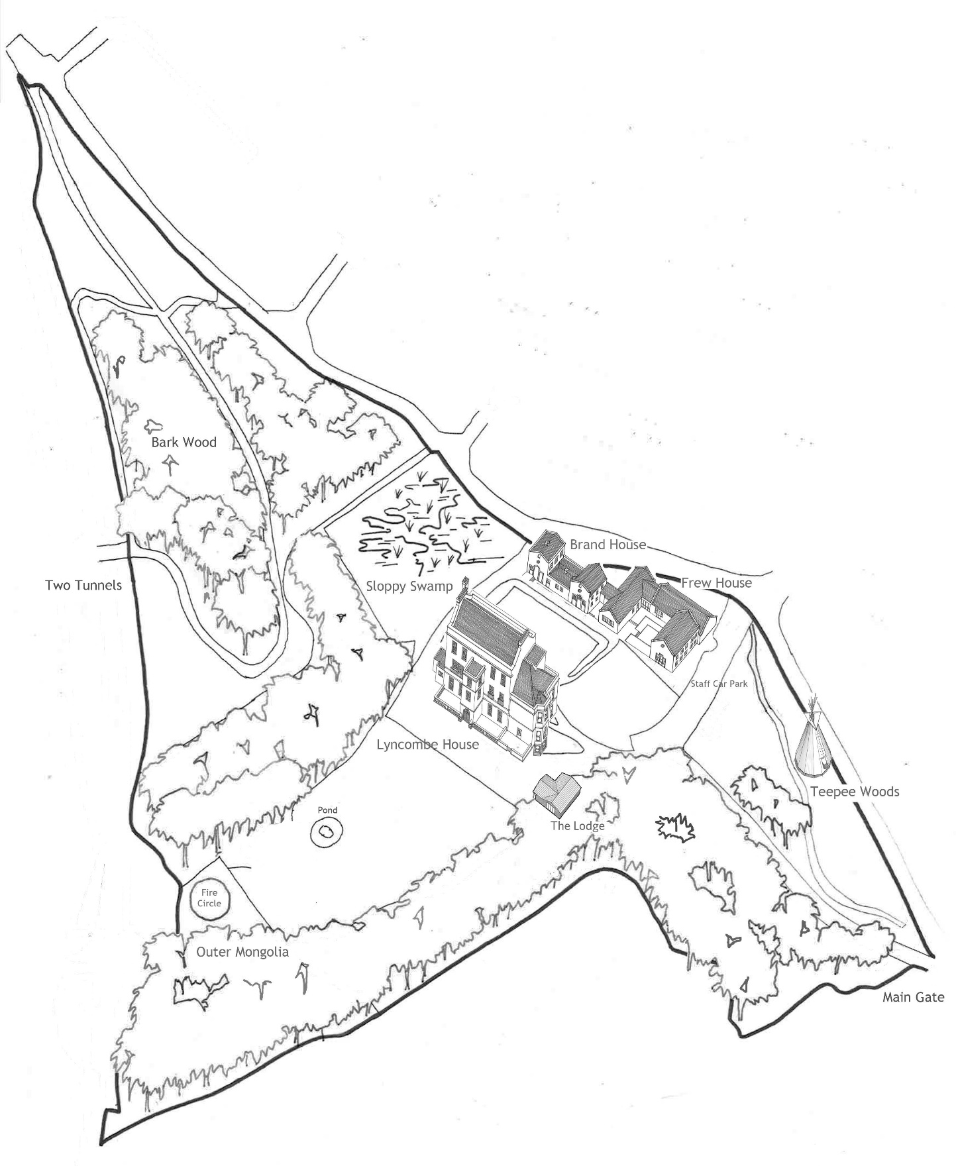

School Site
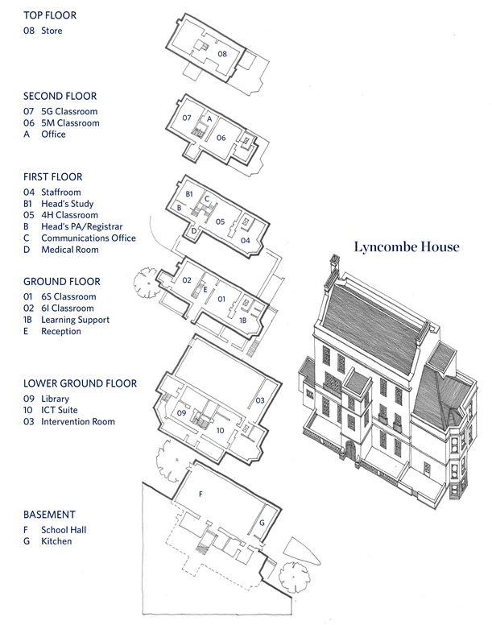

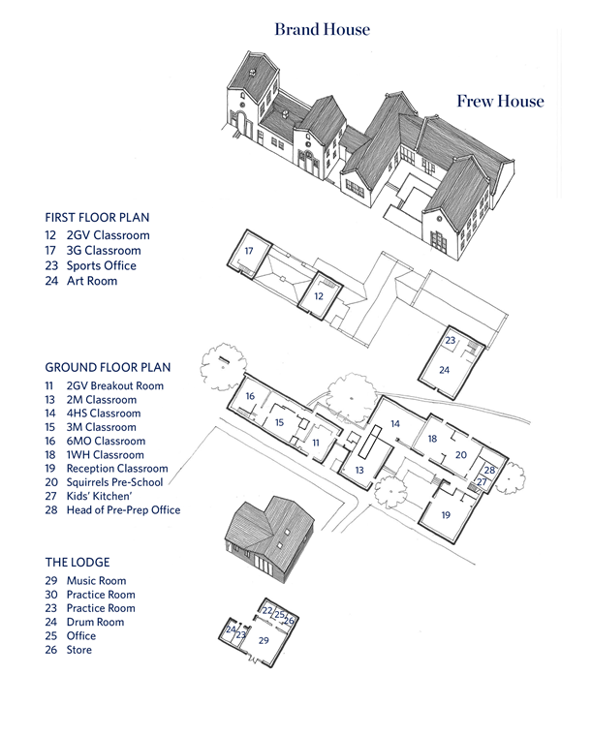

Traffic

Please take note of the one-way system in and out of the school and the unofficial one-way system for the surrounding roads. All vehicles using Lyncombe Vale are requested to observe this traffic code in the interests of improving traffic flow and preserving road safety. This system operates from 8.00 - 9.00am and 3.00 - 4.30pm.
If parked in one of the three parking spaces to the left inside the entrance gate, please exit the school following the one-way system (see Widcombe Association’s map below), rather than leaving via the entrance gate.
PLEASE NOTE: This is an unofficial one-way system and cannot be imposed on our neighbours or other drivers. (See below.)
Other points to remember:
- Drive slowly when approaching and leaving the school, looking out for pedestrians and driving with courtesy for our neighbours; e.g. letting them out of their drives when there is a flow of traffic to/from The Paragon.
- Avoid driving on pavements, which is illegal.
- Have consideration for our neighbours when parking near the school.
- Cars must not be left in the drop off point to the left of the front door of Lyncombe House.
- Only parents of Pre-Prep children should park at drop off. Parents of Prep children (Years 3-6) are requested to make use of the drop off bays. Please do not leave your car unattended in these bays.
- We ask everyone to use the zebra crossing and not cross at any other point of the drive. Please do not park on the crossing.
- Do not walk up/down drive – either use the gate on the right-hand side just inside the main entrance gate and walk along the path through the dell, or use the middle gate at the bottom of the staff car park (code available from reception).
Please walk to school where possible or use the complimentary shuttle bus services from the Prior Park College (8.15am) and Prior Park Garden Centre (8.30am). Please book with receptionists. reception.paragon@priorparkschools.com

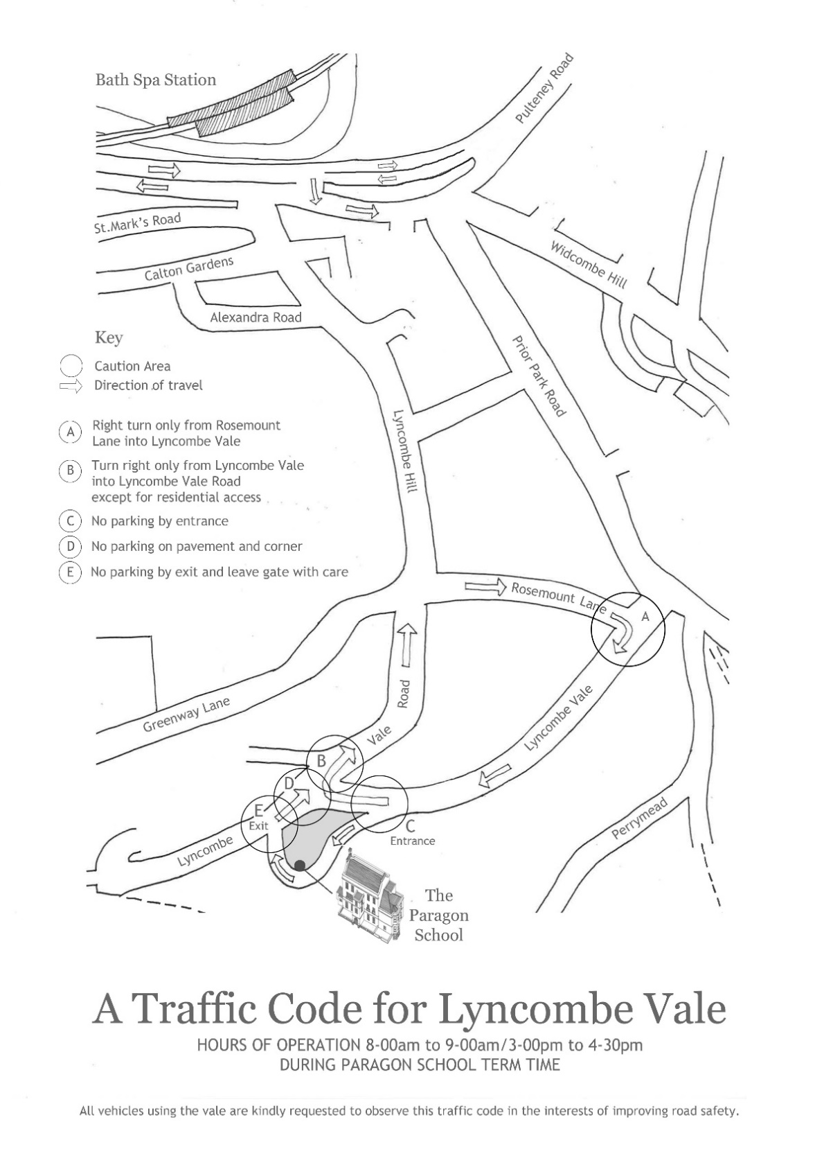

Parking Outside the School
If parking outside the school grounds, please remember to park with consideration for local residents, leaving enough space between your car and the wall to enable pedestrians to use the pavement but taking care not to block the roadway. Similarly, when using the drop-off point outside the middle gate, at the bottom of the staff car park, remember to leave enough room for pedestrians to enter through this gate. If stopping by the middle gate please be aware of pedestrians using this entrance and take great care when manoeuvring in this area.

Parents are asked to park off site if attending an assembly.

Walking to School
We are keen to reduce the amount of traffic entering the school and encourage parents to car share, walk to school or use the minibus services from Prior Park College and Prior Park Garden Centre.

If walking into the school grounds, please enter through the MAIN ENTRANCE, then turn right through the gate and walk through 'Teepee Woods’ or enter through the MIDDLE GATE (ask receptionist for code). For safety reasons, it is important that parents and children do not walk through the staff car park but go through the gate and follow the path beside the Squirrels Pre-School garden and classroom. Please do not enter the grounds through the exit gate. The gates which lead onto the back drive should remain locked at all times.

During the dark winter months, parents who walk to school with their children may like to consider purchasing high visibility armbands which may be worn over coats. These are stocked by The Paragon’s uniform supplier, JMS.

See also: ‘Drop Off’ for information about parking at Prior Park Garden Centre and the morning minibus service from the garden centre and PPC.

Absence

We discourage parents from withdrawing their children from school during term time. Permission must be given by the Head for any pupil absence other than for medical reasons. Email requests for absence to Mrs Braithwaite (rbraithwaite@priorparkschools.com).

Please ensure that all holidays are taken outside term dates.

Parents must email their child’s class teacher for permission if their child is going to miss school for a medical appointment.

Absence due to sickness
Telephone or email the school office on the first morning of sickness to inform us that your child will be absent. The reception phone is manned from 8.00am onwards. The receptionist will inform the class teacher. It would be helpful if you could keep the school advised, on a daily basis, of progress.

Parents are asked to ensure that their children do not attend school if they are ill, or return to school too soon following an illness. In the case of vomiting and diarrhoea, children can return 48 hours after their symptoms disappear. Parents may find it useful to refer to the NHS guidelines, ‘Absence from School’, on this website:
http://www.nhs.uk/Livewell/Yourchildatschool/Pages/Illness.aspx

Although we have a medical room, we cannot leave children there unsupervised for extended periods of time. Therefore, please ensure you are able to pick up your child if necessary or that you leave contact details of a friend or family member who could pick up your child if he/she is unwell.

Extra-Curricular

Although we are not a large school, we offer a fantastic choice of extra-curricular activities, from yoga and chess to pottery and dance. There is also a wide range of games and music clubs which run in addition to the normal weekly sport and music lessons. Staff run over 60 weekly clubs, which are open to as many children as possible, regardless of ability. A few clubs are by invitation only. The emphasis in these activities is on enjoyment and exploring new interests. The clubs programme changes termly and the majority of the clubs on offer are free. Look on the website for details of the clubs for the current term and booking information. Here is an example of our clubs programme for an autumn term:

 | Monday | Tuesday | Wednesday | Thursday | Friday
AM | ‘Sing Out!’ Choir | Senior Brass Group | Orchestra | Joyful Noise | Flute Group
Lunchtime | Music for Fun  Pre-Prep Movers  Wind Band | Tag Rugby  Philosophy  Art Scholars  Clarinet Group  Spanish | Brass Group  Football  Open Art Studio | Junior Sax Group  Flute Group  Samba Band | String Group  Chess  Senior Sax Group  Coding
After school | Activity Club  Drawing  Fencing  Chess  Choir  Swimming Squad  Homework Club | Lego  Yoga  Sporty Boys Club  Sporty Girls Club  Clay  Speech and Drama  Pottery  Paragon Eco Team  Year 6 Study Skills  Homework Club | Singing  Fun Science  Mandarin  Winter Cricket Nets  Homework Club | Groovy Movers  Hockey  Film Club  Rugby  Sporty Girls  Sewing  Homework Club | Construction  Yoga  Cricket  Hockey/Netball  Rugby  Drama  Homework Club  Saturday Active  (at Prior Park  College)  Archery  Swimming  Tennis  African Drumming

Sport, PE and Matches

We provide a wide and varied programme of PE and Games for children throughout the whole school. Our inclusive ethos ensures all children have maximum opportunity to develop physically, participating in lessons and an abundance of sports clubs and school teams.
Lessons
PE lessons: (Pre-School – Year 4)
Children have one PE lesson each week lasting for 30 minutes. These lessons include gymnastics, movement to music, components of fitness (agility, power, strength, balance and co-ordination), circuits, yoga and multi-skills.

GAMES lessons: (Pre-School – Year 2)
Children have one Games lesson each week lasting up to an hour, depending on the year group. The basic skills used in hockey, rugby, football, netball, rounders, cricket, tennis and athletics are taught, as well as catching and throwing skills.

GAMES lessons: (Year 3 – Year 6)
Children are taught a range of core sports and play fixtures against other schools. The lessons usually take place at Prior Park College.

Autumn Term Girls ‐ hockey Boys ‐ rugby (Year 3 boys = Touch Rugby)
Spring Term Girls ‐ netball Boys ‐ hockey
Summer Term Girls ‐ cricket Boys ‐ cricket Co-ed. - tennis

Years 3 and 4 have Games lessons and fixtures on Monday afternoons.
Years 5 and 6 have Games lessons and fixtures on Wednesday and Friday afternoons.

Wednesdays are the main fixture days for Years 5 and 6. Those children not involved with fixtures on a particular Wednesday will participate in a variety of sporting activities at school.

On their sports afternoons, the Prep children should come to school in their Games kit (red polo shirt, shorts, socks, trainers, half-zip top, tracksuit) unless playing in a fixture, when they will need to wear the applicable clothing for that particular match. Parents will be advised in advance if the Wednesday afternoon activity will require alternative clothing such as swimming costumes.

Mouth guards are compulsory for hockey and rugby. Shin pads are essential for hockey and football. The children from Years 3 to 6 must have their own, named and reusable water bottle to take to all Sports lessons and fixtures, as well as a school sun cap during the Summer Term. The children are to supply their own sun lotion.

Sports Fixtures and Sports Clubs
A very important part of our provision of sport is the organisation of sports clubs and inter-school fixtures.

Sports Fixtures
Matches against other schools come in many forms, all providing competitive experiences for all abilities. The school can provide all necessary sports equipment.

One‐to‐one friendly: The Paragon against one other school.
Festivals: Short matches against lots of schools on the same day.
Tournaments: As for festivals but more competitive, with the aim of winning a trophy or medal.

We organise teams in a variety of combinations to suit the ability of the children and the event. Team lists may say:

ALL: Every child in that year group is involved.
U8, U9, U10 or U11: Year 3, Year 4, Year 5 or Year 6. Some children may be selected to play ‘up a year’ if appropriate.
Colts: A combined team of Year 5 and Year 6 children.
Year 3: Have fewer fixtures. ALL children are included in each match. Stronger players may be selected for tournaments.
Year 4: Have a few more fixtures than Year 3. All the children are included however the stronger players are selected for the tournaments.
Years 5 and 6: Have many more matches. Matches tend to be more competitive but all abilities are still catered for.

Teams are selected by ability. Attitude and behaviour during training and at fixtures also play a role in team selection. Please note that throughout the whole season the coach’s decision on team selection is final.
Fixture information can be found in the termly Diary, on the Sports Notice Board and on the website calendar. Alterations and additions to the Fixture List frequently occur. The Sports Notice Board and the website calendar have the most up-to-date details.

Please e-mail Mr Goodman (tgoodman@priorparkschools.com) or Mrs Whyte (kwhyte@priorparkschools.com) if your child is unable to take part in a weekday fixture or a particular Games/PE lesson. Weekend fixtures require a compulsory email from you confirming whether or not your child can play.

Inter‐House Competitions
There are House tournaments in a variety of sports every term and the annual Sports Day is held in the Summer Term. These are lots of fun and every child represents their House with pride and great enthusiasm.

Sports Clubs
Attending the optional sports clubs is important as it allows the children to develop their performance and understanding of each sport. It is not usually necessary to sign up for the clubs unless otherwise stated in the Clubs List.

While clubs are open to all children, regardless of ability, the Games staff may want to work with a specific group of children in order to train for a particular event. These clubs will therefore be ‘invitation only’.

Club information can be found at the back of the school diary, on the Sports Notice Board and on the website.

Where to access sports information
The places to access information each week are:
* The school website: www.paragonschool.co.uk for Sports News, our Code of Conduct (for children AND parents) as well as most up-to-date fixtures and team-sheets.
* The school termly Diary: for fixtures, swimming lessons, clubs list.
* The Sports Notice Board: beside steps outside Lyncombe House ‐ for fixtures, team sheets & clubs
* Twitter: Follow us @ParagonBath
* Facebook: Connect with us @TheParagonJunior

Cancellations or amendments
* Texts are sometimes sent from the school to relay urgent last-minute messages.
* The Fixture Lists on the website (calendar) and the Sports Notice Board will have the most up-to-date fixture information. The details in the term Diary frequently change.

Collection of children
Year 3 & 4 Games
Mondays ‐ pick up from school at 3.45pm unless at a fixture.

Year 5 & 6 Games/PE
Wednesdays ‐ pick up from school at 4.00pm, unless at a fixture.
Fridays ‐ pick up from Prior Park College at 3.45pm sharp unless at a fixture (or 4.30pm if attending a sports club at Prior).
NB: On Fridays, a school minibus will depart Prior Park College for The Paragon at 3.45pm and again at 4.30pm for those children needing to be collected from school.

If a child in Years 3-6 is not collected after lessons, a fixture or club, whether at school or another venue, they will be taken to the Homework Club but must be collected by 5pm. Children will not be allowed to go home with, or be supervised by, another parent unless the latter has that child’s parent’s permission and the school has been informed.

Off Games
Parents of children in Years 3-6 should email Mr Goodman if their child is ever off Games (tgoodman@priorparkschools.com). Children who are off Games will remain at school doing class work under supervision.

School Lunches

The school fees include a delicious lunch cooked daily on site. Our catering team uses local suppliers and cooks fresh produce in our own kitchen. There is always a hot meal, with vegetarian and other dietary requirements catered for on request. There is also a wide choice from our cold buffet bar offering meats, tuna, cheese, salad, etc. There is a pudding of the day or yoghurts and fresh fruit to choose from. We have a ‘no nuts’ policy.
If your child has any specific food allergies, please inform Mrs Braithwaite. rbraithwaite@priorparkschools.com

Snacks

Children are encouraged to bring in healthy tuck for morning breaks. Fruit, vegetables, bread-based snacks, cereal or fruit bars and plain biscuits are all acceptable options. From Year 3 upwards, children should bring in a named bottle of water to keep in the classroom. It is also a good idea for them to have a bottle of water in their games bags, especially during hot weather. Water bottles can be purchased from John Moore Sports.

Birthday treats
We are, of course, happy for children to bring in cakes when it is their birthday. However, we ask that you provide cupcakes, or similar, so that these can be handed out to the pupils at the end of the day. (See ‘Nut Allergies’ below.) This enables parents to decide when their children eat them. Please note that sweets should never be brought into school.

Nut Allergies
Please help us to ensure that nuts are never brought into school, whether in snacks, cakes or other foods. There are children in the school who suffer from nut allergies and if they inadvertently eat a piece of nut, or, in some cases, if they are just exposed to nuts, they will experience very unpleasant and, in some cases, extremely serious symptoms.
Sesame seeds must also be avoided as we have children in school who are allergic to them.

Due to the risk of cross contamination during preparation, homemade foods may not be brought into school for anything other than personal consumption (i.e. for tuck).
Parents may send manufactured food items such as birthday cakes to school for consumption by other children, having first read the packaging label to ensure that there is no evidence that the product contains nuts or ‘may contain nuts’.

Medical Matters

It is the parents’ responsibility to keep the school advised of any medical conditions, allergies or chronic, long term illnesses, including asthma or epilepsy, and any changes in their child’s medical history. Parents are required to complete the Medical Form prior to entry and to provide emergency contact numbers. If, subsequent to the form being completed, your child develops a medical condition, it is most important that the school is informed.

The school may, in certain circumstances, agree to undertake to administer some medicines to children who are otherwise well enough to attend school. Signed consent is required if a pupil is to receive medication during the school day. Please note that we can only administer medication which has been prescribed by a doctor. The consent form can be accessed on the website, in the ‘Useful Information’ section of ‘Parents’ Pages’.

If a child becomes unwell during the school day, he/she will be referred to the school office where a member of staff will contact parents to advise them of the situation and request collection of the child, if appropriate. Staff have undertaken basic first aid training and we have a medical bay where children may rest until collection by a parent.

In the case of bumped heads, the child will be given a wrist band stating: ‘I bumped my head today.’ The receptionist will ring parents to inform them of more serious bumps but will not ring for minor ones. In the latter case, the member of staff dismissing at the end of the day will inform the parents. The wrist band acts as a back up, to ensure that the message gets home to parents.

In the event of a serious accident, school first aiders will assess the injury to the best of their ability and call an ambulance if they believe it to be appropriate, as well as informing the child’s parents.

Uniform

School uniform is on sale at John Moore’s Bath store. Their contact details are:
John Moore Sports, 2 Argyle Street, BA2 4BA.
Opening Hours: Mon-Sat 9.00am – 5.30pm
Telephone: 01225 466341
Email: stitchandprint@johnmooresports.co.uk
Website: https://www.johnmooresports.co.uk/the-paragon-school-t29
John Moore Sports can take orders and offers an appointment system, dedicating a member of staff to each parent purchasing uniform. This service has been put in place to avoid waiting time for parents and to ensure a personalised service for each customer.

JMS has a loyalty card scheme. Parents receive points when purchasing uniform that convert into vouchers which can be redeemed in any of the John Moore Sports Group outlets (John Moore Sports, JMS Rugby). Forms are available in store.

Please see separate uniform list, available on the school website.

Second Hand Uniform Shop
The shop is open on Wednesdays from 3.15-4.15pm during term time. It is located in The Lodge. It is also open on the Taster Day in the summer term. The shop will open by appointment only at other times, subject to availability.
The shop sells The Paragon’s current uniform in good condition. Uniform donations are gratefully received. All the proceeds from donated uniform is split between the school charity and PTA funds.
Fancy dress costumes are also sold (useful for themed days or the Pre-Prep Nativity).
Nitty Gritty nit combs (£5) are available to purchase at the shop.
Donations: Please ensure all items are clean and well presented. We are unable to accept any non-school uniform items, shoes, sports equipment, old style games kit or old badge items. Any items which are not accepted for sale will be sent to charity or recycled. Please bring items to the shop during opening hours or leave in the bin outside the shop at any other time.
Buyers: We accept cash or cheques made payable to Paragon Parents' Committee. Sorry but we are unable to offer refunds or IOUs.
Contact: Lucy Stone. E-mail: paragonsecondhand@gmail.com
Dry Cleaning Offer
Barkers of Bath, 6 Monmouth Place has a special offer. The charge is usually £7.00 for a blazer to be dry cleaned but for Prior Park College and The Paragon’s blazers there is a special offer price of £4.50. This price is only available for school blazers, not other personal items.

Lost Property

We cannot stress enough the importance of making sure your child’s uniform and other belongings are named. Procedures are in place to try to ensure that lost property is returned to the rightful owners but this task becomes almost impossible if items are unnamed. Lost property is put in the area inside the side cloakroom in Lyncombe House.

Hair

The school policy is that boys’ hair should be off the collar, out of their eyes and not too long at the sides. Girls with long hair should wear it tied back with a ‘scrunchy’ or use a hair band. These should be in school colours. We would appreciate parents’ support with this matter, ensuring that the policy is followed.

Head Lice
We periodically have problems with head lice. If we believe a child has nits, we will send a letter to the parents, explaining their child cannot attend school until the necessary treatment is applied to the child’s hair. This can be done quickly and easily. It is important that anyone whose child has nits takes this action. This link may be of help: http://www.chc.org/homedir/thebugbusterkit.cfm
Nit combs can be purchased from the second-hand uniform shop and the reception desk.

TEACHING AND LEARNING

The Paragon offers all children an outstanding level of education. This requires specific attention to the individual abilities, talents and needs of every child, to ensure the intellectual, social, moral, emotional and spiritual development of each individual. Our curriculum is rich and stimulating and is constantly being updated and improved. We believe passionately that school should be fun, that learning should be dynamic and that children learn best when they are happy.

Squirrels Pre-School and Reception make up the Early Years Foundation Stage. The curriculum is play-based and practical, focusing on inquiry, creativity and critical thinking. Early English and Maths skills are taught daily through a variety of songs, games and practical activities. We hope to instil curiosity and a love of learning that will prepare children for the rest of their primary education.

In Years 1-6 pupils are taught the core subjects of English and Science by their class teacher. Similarly, Maths, up to Year 3, is class based and then it is taught in ability sets in Years 4, 5 and 6. The foundation subjects are taught in a cross-curricular context, making learning meaningful to the children.

Art, Languages, Sport, Music, Philosophy and ICT are taught by specialist teachers, giving the children the benefit of a high level of knowledge and skills, whilst continuing to work within a cross-curricular context where possible. French is taught from Pre-School onwards, culminating in the Year 6 cultural field trip to France. Year 5 and 6 pupils also study Spanish and there is a Spanish Club for Prep children.

Lessons provide opportunities for pupils to work independently and collaboratively. Work in class is differentiated so that all abilities are catered for. More able pupils are given extension tasks by teachers, making sure they are stretched and challenged.

We know that everyone is busy and that family time is a precious commodity. Therefore, homework tasks are focused and kept to an age-appropriate length. The emphasis, especially in younger age groups, will be on practising key skills, such as spelling and the mastery of times tables. Daily reading at home is an important part of the homework routine across the school.

Homework

The main emphasis of homework is to reinforce the basic skills taught in school. We encourage parents to ask their children about their homework and to listen to them read. They may also help by practising spelling words and multiplication tables with their children and testing them in these areas. Although we encourage parental support, all children should be able to complete any homework task independently.

Alongside regular reading and weekly spellings to learn, homework tasks may include:

- Multiplication tables practice
- Maths/English/Science/Topic/Spanish/French activity, exercise or thinking task leading on from the classwork completed that day
- DoodleEnglish or DoodleMaths activities
- Project work – continuation of work on an extended project
- Responding to teachers’ comments on previously marked work and occasionally finishing off class work in preparation for the next lesson
Teachers may set homework that needs to be completed by the following day, but they will also make it clear when they are giving children more flexibility, having several days to complete a task (for example, for slightly longer research based tasks).

There is no compulsory weekend or holiday homework set for those children in Year 5 and below but optional extension activities may be offered. In Year 6, there may be a small amount of weekend homework (until all entrance exams have been taken) and holiday homework may be set over the October Half Term and Christmas breaks. The time allowance for homework in Year 6 will be reduced after the entrance exams.

Although reading is not mandatory over the weekend, all children are encouraged to do some reading at home at the end of the week.

We ask parents to let the class teacher know (via the pupil’s exercise books, the Pupil Planner or by email) if their child experiences any problems with homework or if they are spending too much time on it. If a child does not complete the homework within the time limit, it is helpful if the parent, or child, writes a note to the teacher, either using the Pupil Planner, which is a useful tool for home/school communication (from Year 4 upwards) or the Reading Record book/card (up to Year 3). Alternatively, teachers can be emailed, although parents should be aware that teachers are unlikely to be able to read emails during hours of teaching.

Reception | Children take phonics and/or reading books home for reading practice daily.
Year One | 10 minutes reading or sharing a book every day and spelling practice.
Year Two | 10 minutes homework once a week to support class work. 10 minutes reading a book every day plus tables and spelling practice.
Year Three | 20 minutes homework twice a week. 10 minutes reading a day plus spelling and tables practice.
Year Four | 20 minutes homework three times a week. 10 minutes reading a day plus spellings and tables practice.
Year Five | 30 mins homework three times a week (to include a Language homework). At least 10 minutes reading a day plus spellings and tables.
Year Six | 30 mins homework four times a week (to include a Language homework). At least 10 minutes reading a day plus spellings and tables.

In the Prep Department, pupils will be set short spelling activities to complement the spelling practice that they are expected to do. If you would like your child to be provided with additional homework, the class teacher will be happy to discuss it with you.

Curriculum Letters

Curriculum letters are sent out to parents by class teachers each term. These letters explain what pupils will be learning during the term and outline the work to be undertaken across the curriculum.

Curriculum Meetings

Early in the autumn term, parallel class teachers arrange to meet with the parents of the children in their year group to present the curriculum for that year group. Pre-School and Reception teachers arrange a meeting in the summer term preceding entry.
The focus of the meeting is settling children in, and will deal with:
- routines and expectations
- information about the curriculum
- homework schedules
- educational visits

Reports

Children receive two written reports each academic year. The first is produced in December and, as well as reporting on how well your child has settled into his/her new class, it also sets targets for the rest of the year. The second, more detailed report is provided towards the end of the summer term. Teachers write substantial comments about every area of the curriculum, including statements from peripatetic music teachers, learning support teachers and any other people involved in your child's education.
Reports for children in Years 3-6 include The Paragon Grades for achievement in the core subjects. The reports are made available to parents via the school’s Parent Portal.

Parents’ Evenings

Parents’ Evenings are held in the autumn and spring terms. These are formal occasions, run on an appointment system, providing you with an opportunity to discuss your child's performance in all areas of school life and to look at samples of your child’s work. Of course, you are encouraged to make an appointment to see your child's teacher at any time if you have questions or concerns. In the summer term, parents may make an appointment to see their child’s class teacher if they have any concerns, having received the end of year report.

Celebrating Excellence

Celebration Friday
Excellent work is celebrated. If a child produces a particularly good piece of work or has worked especially well on a task, the teacher may send the child to the Headmaster for commendation. Children are also sometimes sent to celebrate particularly good behaviour/acts of kindness, etc. This takes place on ‘Celebration Friday’.

Academic Excellence Display
The Academic Excellence Display is just inside the front door of Lyncombe House. There is a piece of work from each year group, showing off what has been done really well in class. The display is changed regularly so please take a look frequently.

Learning Support

The Paragon provision for children with special educational needs is a matter for the school as a whole. However, if when comparing the achievement, progress and behaviour of a pupil with that of the rest of the class there is cause for concern, or if the teacher and/or parents have concerns, the pupil will be monitored and informally assessed. The Paragon’s SENCo, Mrs Katie Mason, will measure the child’s performance and progress, making use of teacher and parent observations, standardised screening and other assessment tools. Results will be fed back before deciding on the level of intervention required. The child may then be registered to receive learning support or placed on the monitoring register. The majority of pupils taken on show signs of a specific learning difficulty which is preventing them from achieving their full potential (e.g. Dyslexia, Dyspraxia, Dyscalculia, language delay/disorder etc).

Provision varies between in-class support and/or withdrawal for an agreed number of sessions each week. The provision depends on the degree of difficulty the pupil is experiencing and the scheme/programme to be used with the pupil. To target a specific area which needs addressing, temporary classroom-based learning support may be provided by teaching assistants or a member of the Learning Support department at no additional charge to the parents. However, there is a charge made for one-to-one lessons which appears on the following termly account as an extra. (The charge for the academic year 2020-21 is currently set at £20 per 30-minute lesson.)

Where there is one-to-one support from the LS Dept and/or outside professionals, the child will be the subject of a Support Profile (SP). This will be drawn up by a member of the Learning Support Department and the class teacher, in consultation with parents, the SENCO and with input from the pupil. The SP will be reviewed as the child meets the target, and at least once a term.

Where consultation between the school and parents indicates a need for further testing from outside professionals, this can usually be arranged within school but at the direction of the parents. In order to meet the recommendations set out by specialists, the reports must be shared with the Head of Learning Support and other members of staff as necessary. The cost of any assessment, e.g. educational psychologist, or speech and language therapist, is met by the parents.

Educational Visits

We supplement the curriculum with frequent trips around the local area and further afield to make learning relevant and fun for the children. Detailed risk assessments are always undertaken to make such times as safe as possible.

These educational visits - some of which are residential - develop independence and provide a wealth of academic and social benefits, and they are an important and integral element of our educational programme. Therefore, we encourage parents to allow their children to attend these trips.

Year 3 pupils have an enjoyable week of activities during the summer term. They have the opportunity to take part in a number of drama and environmental activities based in and around the school.

Children in Year 4 enjoy an activity week featuring environmental tasks, art projects and
sport activities. For many, the highlight of the week is two nights away, camping at an activity centre.

In Year 5, children spend three nights away on a residential, where great emphasis is placed on developing social skills and, in Year 6, children spend a week in France, reaping the benefits of their study of French throughout the school.

Parents are informed about the cost of visits in advance and the cost is added to school fees.

Outdoor Learning

The school enjoys a beautiful site including seven acres of woodland. Each year group from Pre-School to Year 6 has regular lessons in our grounds in all areas of the curriculum. The Paragon has ‘Forest School’ status and many of our teachers have undergone Forest School training. In addition, we have close links with local organisation, Swainswick Explorers (www.PlayingOutdoors.org). We employ one of the leaders of Swainswick Explorers to work with our classes, on site. Outdoor learning is an exciting and integral part of life at the school.

Ticks
As the children sometimes use the front lawn and enter the edges of the woods during lessons and at breaktimes, parents are asked to be alert for ticks. Teachers will also ensure children check for ticks after they have been in the woods or on the front lawn. You may wish to refer to this website, which provide useful guidance: https://www.nhs.uk/conditions/lyme-disease/

Music

The Paragon School is widely acknowledged as offering outstanding musical opportunities to its pupils. The emphasis on all music making is having fun, being prepared to have a go and learning to share the enjoyment of making music together. All children receive weekly class music lessons which cover a varied curriculum: these lessons are taught by a music specialist.
We are extremely fortunate at the school to have a superb team of peripatetic music teachers, who encourage and inspire their pupils to reach their musical potential; currently, around 75% of children in Years 2-6 have lessons on at least one instrument, with a number of children in the lower part of the school having lessons too. We are able to offer lessons on the violin, cello, flute, clarinet, saxophone, cornet, trumpet, trombone, drum kit, guitar, bass guitar, piano, and voice. We have a selection of school instruments which can be hired; all other instruments should be purchased or hired privately. There are no restrictions on children starting lessons on a particular instrument; the deciding factor is largely one of child size.
As soon as the children are ready, they are encouraged to join our music groups. Currently, we offer three choirs, orchestra, wind band, samba band, African drumming and groups for strings, woodwind, brass and guitars. Parents and staff are encouraged to take part in some music activities, where they act as positive role models for the children.
Children are encouraged to take every opportunity to perform to an audience, be that in the more formal setting of an organised concert or at our informal Thursday lunchtime recitals. Our ‘Sing Out!’ group of children and parents visit a local care home on a regular basis and our instrumental groups have provided entertainment at a local garden centre and for shoppers in the city. We take the opportunity to perform with students from Prior Park College when we can and have taken part in a number of large-scale College events including ‘Noye’s Fludde’, ‘Wassail’ and ‘Ahoy!’ Children are encouraged to take part in local music festivals where they can participate with other schools.
The well-resourced and enthusiastic department provides opportunities for all pupils to enjoy music at their own level, whilst ensuring there are opportunities for gifted musicians to develop their talents as soloists and ensemble players. It also draws on the expertise of external teaching resources such as the Bath Abbey choral programme which complements our diverse range of music projects.

PASTORAL CARE

Nothing is more important than the pastoral care within a school.

We want every child who comes here to feel loved, encouraged and valued - valued for who they are regardless of their ability in the classroom or on the playing field.

Katie Mason (SENCo) has overall responsibility for pastoral care in Years 4 –6. Magnus Hinde has specific responsibility for boys’ pastoral care in the Prep Department. Rose Barnes has responsibility for girls’ pastoral care in the Prep Department. Sarah James has responsibility for pastoral care for boys and girls in the Pre-Prep Department and Year 3.

Behaviour Aims

We have high expectations of all our children and firmly believe that their social and moral development is every bit as important as their academic development. In short, life at The Paragon can only be exciting and enjoyable if behaviour and manners are excellent from top to bottom.

We expect every member of this school community – children, staff and parents – to show considerable respect and courtesy to others. We recognise that, as adults, we need to model this; it is the way we treat others that will be seen and imitated by the children.

We are always encouraging, rewarding and celebrating good behaviour. A rewards system is in place whereby children receive a range of stickers for behaviour, effort in schoolwork and for showing attributes of ‘The Paragon Way’. Over the course of the term, the children attain a number of stickers which will go towards earning individual certificates that will be awarded in assembly. When a child achieves their first 30 stickers they will earn their Bronze certificate, then the child will move on to Silver, Gold, Platinum, Diamond and finally, Emerald. Each certificate is worth 30 stickers.

We do not believe in endless, lengthy school rules that are difficult to remember. However, we have ‘The Paragon Way’, a set of values which we aim to inculcate in all our pupils. The various themes it lists are explained in school assemblies and discussed in class. The same list is used, in an age-appropriate way, across the Prior Park Schools.

The Paragon Way:
- Treat other people as you would like to be treated
- Forgive
- Share
- Be honest
- Listen
- Show good manners
- Be kind and helpful
- Be your best self

Sanctions

Despite behaviour being very good at The Paragon, occasionally things do go wrong. We have a Behaviour Policy which clearly sets out the procedures we follow with discipline issues. This is available to parents on the school website. With all of our policies and systems, we very much hope common sense prevails.

Minor infringements of school rules - for example noisiness, tardiness, untidiness - are addressed through teacher/pupil dialogue. A verbal apology will usually be required. Children will be given a series of warnings before punishments are introduced. Teachers may record the child’s name on the board as part of this warning process. From Year 3, the ‘traffic light’ system is used.

If the behaviour is consistently poor, the teacher will inform the child’s parents and a behaviour chart may be used. In this case, every lesson and breaktime is then reported on and graded. Privileges will be withdrawn. These include school representation, participation in extra-curricular activities and school visits. At this stage, there will be close, ongoing communication between school and home.

If a child has been put on report for a third time, the Head, in consultation with the Governors, may request the removal of the child from the school. Parents will be kept abreast of the situation during this process.

Bullying

There is zero tolerance of bullying at The Paragon. We have a clear and effective counter-bullying policy which outlines how we firmly but fairly deal with such behaviour, while also offering support and protection to those who may have been bullied. The counter-bullying policy is available to parents on the school website.

GENERAL INFORMATION

Spiritual Life

The Paragon was founded as a Christian school and the Christian ethos underpins our values and attitudes, both inside and outside the classroom. It's at the heart of who we are and what we do. Having said this, we warmly welcome children of all faiths - or no faith at all - and are very much an inclusive rather than exclusive school.

In school we have a box by the front door for confidential prayer requests from anyone and everyone. We have visits from local vicars and welcome visitors to talk about non-Christian faiths in our assemblies. Our RE syllabus looks at the customs and beliefs of all the major religions and encourages children to ask some of the big questions about life. ‘The Paragon Way’ set of values is based on Jesus’ Sermon on the Mount and the Beatitudes.

Assemblies

Assemblies are key times in the week, helping develop the pastoral and spiritual life of the school. Assemblies provide opportunities for staff and children, across the age groups, to come together to remind ourselves of our core values.
Our assemblies sometimes have a more explicitly Christian focus, while at other times they focus on an important moral message. We want to help all children distinguish between right and wrong, to develop a sensitivity and awareness of the needs of others and, above all, to make them feel loved and valued as unique human beings. We also want to enable our pupils to develop an awareness of our multi-cultural society and the ‘global community’, whilst enabling them to grasp fundamental British values and how they relate to life in school and beyond.
In assemblies we often celebrate children’s achievements and sometimes watch class performances. Assemblies take place as follows:
Monday: Reception – Year 6
Wednesday: Reception – Year 2
Thursday: Years 3 – 6
Friday: Reception – Year 6 (and Squirrels occasionally)

Library

We offer your child a range of…
- Picture books
- Fiction
- Non-fiction
- Audio books
...as well as the opportunity to read about current affairs, in First News, and The Week Junior.

Pre-Preps visit the Library with their teachers once a week and can borrow up to two books at any one time.

Prep children visit the Library once a week for a session with the school librarian, during which time they discuss fiction and practise research skills, as well as having the chance to borrow up to three items.

They can also access their own Library account from home, by downloading a free app 'iMLS' or from the following website: https://u002299.microlibrarian.net to see what books are available, the new additions, and to write reviews, as well as having access to a choice of educational websites.

The Library also opens at lunchtimes from 1.15 -1.45pm.

House System

A house system operates from Year 3 upwards. All children in Years 3 to 6 are allocated to one of the four school Houses:
ABBEY CRESCENT HOLBURNE MILSOM

Houses compete against each other in sports and other events. Stickers awarded to children for behaviour and effort count towards the weekly house total and a cup is awarded to the house with the most points each half of term, with the house earning the most points at the end of the year being awarded the House Shield.

Each house has a House Captain and Deputy who are voted in by the members of the house on a termly basis. House assemblies, led by the House Captains, are held each half term. Occasional house activity sessions take place, during which the children participate in team building tasks, working alongside members of their house from other year groups.

School Council

The School Council is made up of one representative from every class from Years 3 - 6. Each rep is democratically voted by the rest of the class and the council then meets with the Head in her office every half term. The representatives bring to these meetings ideas or issues which they, or their class, feel can help move the school forwards. Together they normally have a good discussion about all manner of school issues over a plate of chocolate biscuits! The class reps wear a special badge for the duration of the time they are on the School Council.

School Council members also attend Food Committee meetings, which are held once a term. At this meeting they pass on their class’ comments and requests regarding school lunches to the chef and the Assistant Bursar.

Holiday Activities

Holiday Clubs
In holidays the school also runs activities for the children. These are at an incremental cost and include Camp Teepee, The Paragon Art School and The Paragon Cookery Club. To find out more and to book your child into holiday activities, go to https://www.paragonschool.co.uk/holiday-clubs.

Camp Teepee
These are exciting outdoor adventure day camps for children aged 6-11. The children learn new skills, develop their confidence and have a great time in a safe outdoor environment. Previous activities have included fire lighting, trails to buried treasure, campfire songs, smelly potion concoctions, raft building for a crew of jelly babies, wooden stick carving, camp fire cooking, wild drumming, woodland detective games, shelter building, fireside jam doughnuts, clay creature crafting... and many more. Each day the children make something to bring home as a memento, as well as a pile of muddy clothes and a huge grin.

Paragon Art School
Art experiences suitable for different age groups. All are led by our Head of Art, Miss Alex Hucks. The children will have a creative and busy day where they acquire new art skills and will bring home a piece of work worthy of display.

SuperPirates
The children’s entertainment company provide holiday activities in The Paragon’s grounds. To find out more about what they offer and the dates go to www.superpirates.co.uk.

Home-School Links

At The Paragon there’s a clear focus on the whole family. We want the links between home and school to be really strong.

We encourage parents to get involved in the life of the school because we believe school should be fun for mums and dads too! For example, there’s a ‘Sing Out!’ club and school orchestra for children and parents, a dads' cricket match, Mummy Monday and Father Friday. There are lots of opportunities to come into class to help or you can volunteer to lead an assembly to talk about your job, a hobby or whatever you feel passionate about.

Each class has a Class Rep (a volunteer parent) who helps coordinate social events for the parents. Please ask your class teacher for the Class Rep’s details. For new families, we provide the details of a current family, within your child’s class, who will act as ‘buddy parents’. They will make contact with you before you join the school to help with any questions.

Parent Volunteers
Please note the current regulations regarding parent volunteers:
- Parents who help in school no more than three times a month, and are supervised at all times, do not need a check by the Disclosure and Barring Service (DBS).
- Parents who help frequently (more than three times a month) must have a DBS check and undergo the full recruitment process.
- Parents attending overnight stays on school trips must have a DBS check.

If you would like to help more than three times a month, please contact Kasia Niec, the HR Administrator at Prior Park College (kniec@priorparkschools.com).
It is important that we keep a log of how often parents help in school. Any parent helping in
school must report to the receptionist so that a record of attendance can be kept. This is, of course, also important for fire safety reasons.

Parent and Teacher Association

The Paragon PTA is a friendly group of parents, who meet a couple of times a term to organise social activities for the whole school and to fund raise for The Paragon and our chosen charity. They usually meet in a classroom at school and new faces are always welcome!

The PTA aims to organise a variety of events in the hope that there is something on offer for everyone. From children’s discos through to quiz nights and Easter egg hunts, we’re sure you’ll find something to participate in!

Its members also run the Thursday café between Easter and October half term, where you can drink tea and proper coffee, whilst chatting to other parents and watching your children play.

All funds raised are split between the school’s charity, which is currently ‘RUH Forever Friends’, and The Paragon.

So if you fancy getting involved (we promise it’s not a lifelong commitment!) look out for
details of the next meeting in the weekly bulletin, or email the Chair of the PTA, Lucy Stone. ptaparagon@gmail.com

Compliments and Complaints

It is always pleasing to hear from parents regarding any area of school life that is going particularly well. Compliments boost morale and we are always delighted to receive positive feedback whether it is verbally, by email or letter.

We also recognise that there are always things that can be improved and refined, so we welcome constructive feedback which helps us move the school forwards. We hope you will find The Paragon a school that is both accessible and good at ‘listening’.

We also know that children’s and parents’ concerns can sometimes be of a serious nature and so a detailed Complaints Procedure is available on our website. This policy explains how both informal and formal complaints are handled.

IAPS Membership

The Paragon School is a member of The Independent Association of Prep Schools. IAPS is the professional association for Heads of the leading 600 independent prep schools in the UK and worldwide. Accreditation as an IAPS prep school provides an additional mark of quality.
Whatever the particular ethos of a member school, parents can be sure of a high quality of teaching and learning, a high degree of specialism in many subjects and phases of education, and generous resources, not least in the school's adult:child ratio. For more information about IAPS visit www.iaps.org.uk.

School Crest

